Miradi Database Suite Instructions

Developed by David Berg
for The Nature Conservancy
and the Greater Conservation Community

Contained in this package are [at least] the following six files, most of some numbered version:

- Miradi m.n Database.sql
- Miradi Database Upgrade Script.sql
- schema.rnc
- Install_Import.sql
- Import_XML.sql
- TableDumps.qbquery
- TestSuite.qbquery

Miradi m.n Database.sql drops any previous version of the Miradi Database and creates the Miradi Database compatible with Version m.n of Miradi; creates and populates the table MiradiTables, which is a meta-data table containing a list of all the tables and views in the Miradi Database; installs a number of User-Defined Functions; and installs the stored procedure sp_DeleteProject(), which will remove a project completely from the database.

The database, scripts, and queries are developed with MySQL Version 5.0 and likely contain MySQL extensions to ANSI SQL that may or may not be compatible with other ANSI SQL products.

Miradi Database Upgrade Script.sql upgrades the previous release of the Miradi Database to match the contents of Miradi m.n Database.sql

Schema.rnc is the XML Schema from which the Miradi m.n database is derived.

Install_Import.sql contains the stored procedures required to import a project into the Miradi database: sp_Parse_XML, which parses the XML data stream for a project into element names and values; sp_Iterate_XML, which iterates through the parsed XML stream to populate the database; and sp_StrategyThreat, which traverses the diagram links to determine Strategy x Threat, Strategy x Target, Objective x Threat, Objective x Target, and Threat x Target associations..

Import_XML.sql is the driver to import a project into the Miradi Database. It reads an XML data stream into a temporary table, ProjectXML, and successively calls the procedures sp_Parse_XML, sp_Iterate_XML, and sp_StrategyThreat (which are also likely contained in this package).

TableDumps.qbuery contains a series of queries that list the contents of each table and view in the database.

TestSuite.qbquery contains a series of SQL queries that produce result sets matching the contents of each screen/view/window in the Miradi product. This file is a continuous work in progress and will be updated regularly.

Installation and Operating Instructions

Examples are shown using MySQL client products. They will likely differ for non-MySQL clients.

- Extract the contents of the Miradi Database Suite into the directory from which you will execute its database scripts and queries.
- Install the Miradi Database OR upgrade the previous release of the Database.
  - Read the Miradi Database script OR the Miradi Database Upgrade script into your client and execute it.
From the MySQL Workbench, File → Open SQL Script → Miradi 3.3 Database.sql; then press the Execute Button.

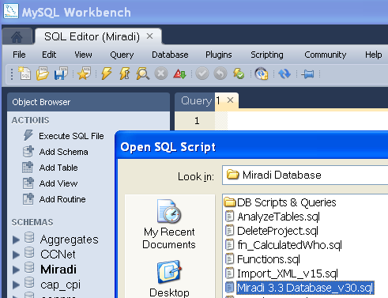

From MySQL Query Browser, File → Open Script → Miradi 3.3 Database.sql; then press the execute button.

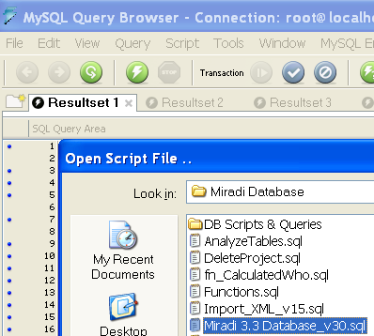

- Install the stored procedures required for importing a project.
Read Install_Import.sql into your client and execute it, in the exact manner as you did with the database schema. File → Open Script → Script Name → Execute
- Export a Miradi project in XMPZ format into the directory from which you will import it into the database. File → Export Current Project as → XML Miradi Project ZIP → Export → Save XMPZ.

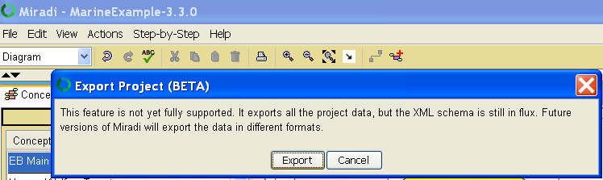

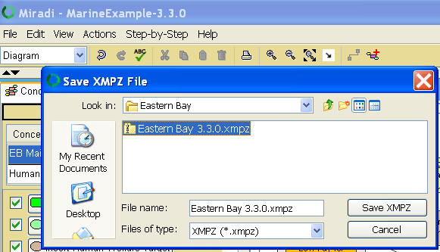

NOTE: When I install Miradi, I uncheck the box that associates an XMPZ file with Miradi so that it remains associated with the operating system’s compressed file program. However you associate the XMPZ file with a program to process it, you’ll need to be able to extract files from within it.

- Open the XMPZ zip file with your compressed file extract program and extract the file project.xml from it.

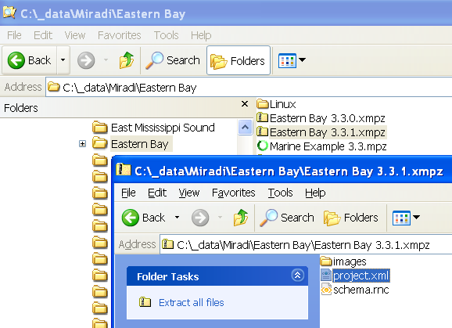

- Now you’re ready to import your project.
  - Read Import_XML.sql into your client using the same technique as you did in Steps 2 and 3.
  - Locate the statement ‘LOAD DATA INFILE … .’

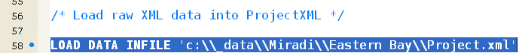

  - Change the directory (and file) name in this statement to the directory where you extracted the file project.xml (or if you renamed the file).
  - If you exported the XMPZ file using a Linux operating system, you’ll also need to change the line delimiter string in the LOAD statement by uncommenting the appropriate line delimiter string and commenting the other.
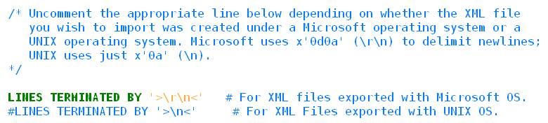
- Now you’re ready to import your project. Just press the Execute button on the script Import_XML.sql.

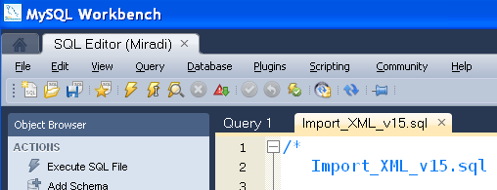

This script reads the XML data stream into a temporary table named ProjectXML; executes sp_Parse_XML to parse its contents, placing the parsed results into another temporary table named XMLData; executes sp_Iterate_XML to iterate through the parsed contents and insert rows into the tables corresponding to each Object or Factor represented in the data stream; and then executes the stored procedure sp_StrategyThreat.sql to populate Strategy x Threat, Strategy x Target, Objective x Threat, Objective x Target, and Threat x Target associations.

- Now you can read TableDumps.qbquery and TestSuite.qbquery into your MySQL client to list the contents of the database.

